How to Tune a Guitar
Tuning the guitar is vital to sounding good. Here are some simple instructions that explain guitar tuning basics. The open strings of a guitar from the thickest to thinnest are as follows:
- E – the thickest or lowest sounding string is known as the 6th string
- A – is the 5th
- D – is the 4th
- G – is the 3rd
- B – is the 2nd
- E – the thinest or highest is the 1st
The most common method for tuning both Electric and Acoustic guitars – and the one you can use when no other instrument or guitar tuner is at hand is:
Online source for string pitches: http://www.howtotuneaguitar.org/

Standard Guitar Tuning Method

Step 1: The E String
Tune the bottom E, as accurately as you can. Chances are it’s in tune anyways, being the thickest string it’s the least likely to detune itself than any of the others. If you have another instrument such as a Piano, you can tune it to the 1st E below middle C. If you have no device or instrument handy just try to get it as accurate as possible, what really counts when you are playing is that the guitar is in tune with itself and any other instruments you might be playing with.

Step 2: The A String
Place the first finger of your left hand just behind the fifth fret on the bottom E string. That’s the note A. Keep your finger on that fret. Now pick the fifth and six strings in turn, gently adjusting the fifth string tuning peg until the two notes are the same. Listen for the wave vibrations to be in-sync with each other.
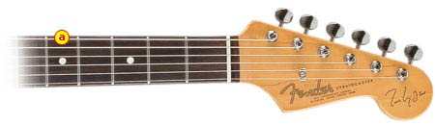

Step 3: The D String
Place the first finger of your left hand just behind the fifth fret on the A string. That’s the note D. Tune the 4th string (the D note) to that.
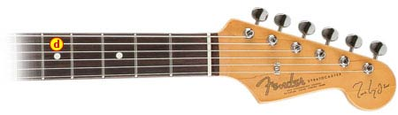

Step 4: The G String
Place the first finger of your left hand just behind the fifth fret on the D string. That’s the note G. Tune your G string to that note.
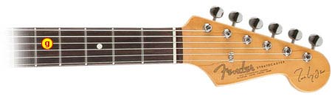

Step 5: The B String
Place the first finger of your left hand just behind the forth fret. That’s the note B. (note the B string is the only one that comes from a different position the forth fret, the rest are from the 5th fret).
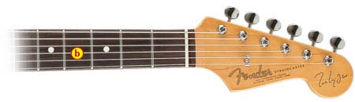

Step 6: Tuning the E String
Place the first finger of your left hand just behind the fifth fret on the B string. That’s the note E.
