Chapter 1 Worksheet “What is sound?” Name ________________________

The three main components of sound are 1. _________________________
2. _________________________
3. _________________________

Define each of these:
1.____________________ _________________________________________________________________
________________________________________________________________________________________

2. ____________________ ________________________________________________________________
________________________________________________________________________________________

3 ___________________ _________________________________________________________________
________________________________________________________________________________________

Compression: _______________________________________________________________________________
_______________________________________________________________________________________________

Propogates: _______________________________________________________________________________
_______________________________________________________________________________________________

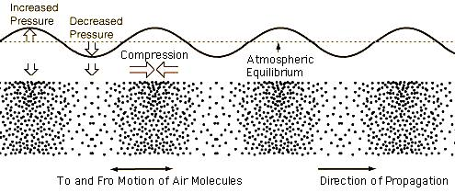

The opposite of compression where molecules decompress is called: __________________

What is the difference between a compression wave and a transverse wave? _________
_________________________________________________________________________________________________
_________________________________________________________________________________________________
_________________________________________________________________________________________________

Sound generation by Musical Instruments:

Explain how the following instruments create sound waves:

Drums, cymbals: _____________________________________________________________________________
_________________________________________________________________________________________________
Bowed instruments: (violin, cello, bass):___________________________________________________
_________________________________________________________________________________________________
Reed Instruments (saxophone, clarinet): __________________________________________________
_________________________________________________________________________________________________
Flutes _________________________________________________________________________________________
_________________________________________________________________________________________________
Brass Instruments: __________________________________________________________________________
_________________________________________________________________________________________________

___________________ is the tendency of a system to oscillate at a greater amplitude at some frequencies than at others.

Fill out the ear diagram

